|  |  |
| --- | --- |
|  | Cat. Org. Documentation |
|  |  |
|  | Ilyaas Davids |

Contents

Introduction ………………………………………………………………………………………………… Pg 2

App Overview ……………………………………………………………………………………………… Pg 3

Application Features …………………………………………………………………………………… Pg 4

Application Requirements ………………………………………………………………………….. Pg 5-6

Use Case Diagram ………………………………………………………………………………………Pg 7

UI design mockups …………………………………………………………………………………… Pg 8-14

Navigation Diagram ………………………………………………………………………………… Pg 15

Project Plan ……………………………………………………………………………………………... Pg 16

Conclusion ………………………………………………………………………………………………. Pg 17

References ……………………………………………………………………………………………… Pg 18

**Introduction**

What is a hobby? A hobby is a routine leisure activity that one engages in for enjoyment [Merdeka, 2022] and can be anything from fishing to reading books. We often overwork ourselves and feel that we need to relieve stress which can be done through the pure enjoyment of our hobby. Collecting items is a common hobby that is practiced through various genres of entertainment, sport, motor vehicles and more. Collector’s items are often rare items that are hard to come by and are very expensive thus drawing collectors closer to it. Collections are sometimes difficult to manage as they can grow very big and become easy to lose track of specific editions and the items that belong to those editions.

We were tasked to develop an application that would aid users in managing items that they collect by sorting items into categories making it easier for these items to be identified. The application would also need to make use of the camera function to capture these items making it more appealing to the user. Adding a caption/description of the item along with a picture of it would help the user to understand the item and the value behind it.

It is important that good programming practices are utilized in order to achieve goals and milestones whilst improving the quality of the application simultaneously with the ultimate goal being the implementation of a successful application. With proper planning and execution this will be possible.

**App Overview**

As mentioned in the introduction, the purpose of the application is to help manage collections of the user by documenting it dynamically through an image taken by the user. The user should be able to add a description below the image to give context of the significance of item in the image. They should be able to also categorize each collection so that it may be easier to navigate to the desired collection. It is important that the use of color be implanted to the application as color coding is a good method of organization. To safeguard the user’s information, a log in feature is required which will be used each time the application is run. An achievement system is a great way of promoting positive reinforcement to the user and it is important that it is implemented. This way the user can keep track of the number of items in each category and/or work towards a goal count.

**App Name and Icon:**

**Name:** CAT. ORG.

**Application Features:**

* **Sign up feature**: Although this was not mentioned in the requirements, I would like to add a sign-up feature which would prompt the user for a username and password which will then be stored in the database and be used when the user tries to login. The password will also be hashed in the database for protection against possible cyber-attacks.
* **Delete feature**: The user should be able to delete items or categories of their choice. It is very possible that the user could make some type of error that they would like to correct by deleting the item/category or they are no longer interested in completing a certain category and would like the remove it.
* **Favorite feature**: When a user favorites a category, the selected category appears at the top of the list with a star next to the category name indicating that it has been favorited. Only one category can be a favorite at a time. This way the user can also focus on a single category at a time and not be overwhelmed.
* **Edit feature**: The user can press the edit button to correct mistakes like spelling errors and assigning the wrong image with an item. This would save the user time by allowing the user to edit the mistake on the same page instead of having to delete the category/item and then creating a new one.
* **Stats feature**: This will display the stats of the user to indicate milestones and goals achieved. For example, “Number of items added: 0” or “Achievements completed: 2”. This way the user can keep track of their historical figures and appreciate their progress.
* **Tips and tricks message feature**: When the user opens the application a random message that contains a tip or trick will be displayed to help the user understand the application better and help them to take full advantage of its features.

**Application Requirements**

* **Log in:** The user must be able to login to the application with a username and password which will be stored and retrieved in a database. The password will also be encrypted to protect against possible cyber-attacks.
* **Create categories**: The user should be able to create and name categories. These categories will act as containers for the items uploaded by the user. This helps the user to better manage large amounts of items.
* **Set a goal for number of items they want to own in each category**: By setting a goal for each category the user is given an objective to work towards making the application more interactive. This also allows the user to manage the number of items that each category can hold.
* **Add new items to collection**: When the user wants to add a new item to a collection, they have to provide information which will be used to place the item in a specific category along with a date and description which will be used for documentation purposes. All these fields must be entered when adding a new item so exception handling must be exercised.
* **View list of items in collection**: When the user taps on a collection they will be prompted to a new page which will display each individual item within the collection. Each item will contain an image with a description and a date which the item was added on. The list view provides the user with a visual pleasing way to view every item in the collection.
* **Take and store an image**: Only displaying the name of the item would give very little context about the item therefore the user must be able to take a picture of the it which will then be added along with the description and date that it was added. Camera access must be enabled for this feature to work.
* **Display goal progress visually**: Goal progress is important to the user as it gives them an indication of their progress therefore it must be displayed to them in a visually appealing manner such as having a progress bar under each category name.
* **Achievement system**: An achievement system is a great way to get the user to interact more with the application by giving them milestones to work towards. This promotes encouragement for the user to do more such as adding more items to categories to earn achievements.
* **Online database**: It is important that the data is stored in a database and not in memory as it will be deleted once the application stops running therefore a database must be created in which the categories, items, pictures and login credentials will be stored (some statistical information will also be stored in the here as well).
* **Biometric login system**: Many smartphones use a biometric system to gain access not only to the phone itself but to other sensitive information within the phone itself (such as the password vault in the “settings” app). This feature would further help to bolster the security of the application and provide users with a quicker way to safely gain access to the app. [Makarov, 2022]
* **Search feature**: The search feature is a must-have for any mobile application especially those that contain lots of information and could potentially cause navigation problems to the user. The search feature provides a quick and effective way for the user to retrieve a specific item instead of having to manually navigate to the desired item. [Sims, n.d.]
* **Push notifications**: Provides a way for the application to engage with the user even when the app is not in use. Push notifications remind, inform, and update the user about events that take place within the application thus drawing them closer and making them want to use the application more frequently. In the case of our application, this feature can be used to update the user on the achievements progress and category completion as well as provide them with some statistical information such as: displaying the number of items collected in a specific timeframe or encouraging the user to create more categories so they can collect more items. [Korzen, 2022]

**Use Case Diagram**

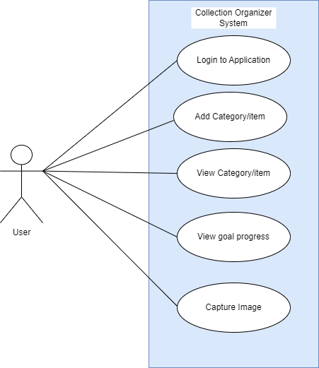

**User Interface Design Mockups**

**Login Page**:

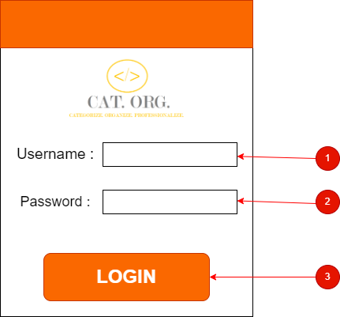

**Description**: The login page is used as a roadblock to prevent unwanted users from accessing the application. The user must enter a username **[1]** and a password **[2]** which must match the details stored in the database. Once details have been entered the user taps the “LOGIN” button **[3]** to proceed to the Home Page.

**Home Page**:

**Description**: When the user wishes to view their collections they will tap on the “View Collections” button **[1]** which will display all the categories that the user has created. To add a new item the user taps on the “Add Item” button **[2]** which will navigate them to the “Select Category Page”.

**Select Category Page**:

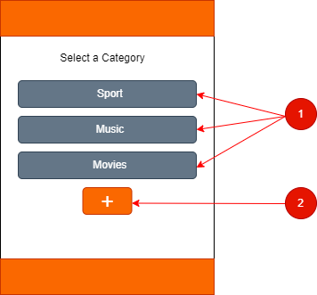

**Description**: The user can select a category of the item which will navigate them to a page which they will be able to capture more details of the product **[1]**. The user can also add more categories to the list, however this button will be unavailable when the user chooses the “View Collections” button on the previous page **[2]**.

**Add Category Page**:

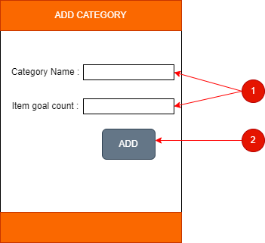

**Description**: The user must enter details of the category they wish to add **[1]**. Once the user taps on “ADD” **[2]** the category will be added to the list in the “Select Category” page.

**Add Item Page**:

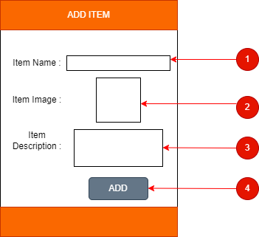

**Description**: The user must add an item name **[1]**, an item image which can be added using the cellphone’s camera **[2]**, and an item description to give context about the item **[3]**. When the user has filled all the required fields they tap on the “ADD” button **[4]** to add the item to the category which was selected on the previous “Select Category” page.

**View Items Page**:

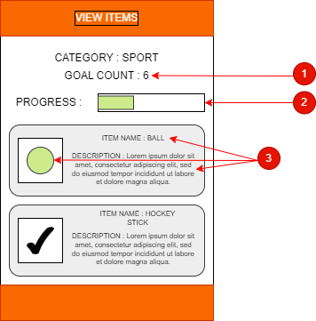

**Description**: The goal count is displayed to show the user how many items the category will hold **[1]**. The progress bar shows the user how far they are to reaching their goal in a visually appealing manner, the bar changes based on the number of items in the category comparing it to the goal **[2]**. Each container displays the item details to the user which includes: an item name; item image and item description **[3]**.

**Navigation Diagram [ REDESIGNED]**:

**Project Plan**

Gantt Chart:

Conclusion

The ultimate goal of any project is success through hard work, communication and dedication. The final product should meet all the requirements that was requested during the planning phase. As developers we should strive to meet these requirements as well as exceed them by doing more than requested which would benefit and satisfy both parties. It is also important that we plan well as we would most likely find ourselves referring to project plan documents when we reach obstacles. Most developers struggle with communication between each other which would make overcoming obstacles much harder to do. It is always important to practice good communication through daily stand-ups where employees can inform other employees about the work they have done, problems they have face and how they plan to overcome these problems.

In conclusion, as long as we work at a steady pace, complete all the deliverables and reach each milestone there should not be any worry of the project failing. Failure of this project would only be a result of lack of hard work and willingness to succeed.

References

1. Merdeka, R. 2022. What is Hobby?- Definition, Benefits, and Types of Hobbies. GreatDayHr. <https://greatdayhr.com/en-en/blog/what-is-hobby/>.
2. Gantt Chart tutorial: <https://www.youtube.com/watch?v=-oD50HSBBBI>
3. Makarov, A. 2022. Mobile App Development Trends and Innovative Features in 2023. Mobidev. <https://mobidev.biz/blog/mobile-app-development-trends-key-features>
4. Sims, B. ND. 15 Modern Mobile App Features That Can Change How Users View Your App!. Cerdonis. <https://www.cerdonis.tech/blogs/13-modern-mobile-app-development-features-and-requirements/>
5. Korzen, Karol.2022. Benefits of push notifications.CrustLab.<https://crustlab.com/blog/benefits-of-push-notifications/>